Section 1: 10 Questions (2 marks each)

1. c) SUM
2. a) $
3. c) Sparklines
4. a) Counts the number of cells in a range that are not empty
5. d) Image
6. c) Ctrl + 1
7. a) MAX
8. c) Macro Recorder
9. b) CONCATENATE
10. a) Searches for a value in the first column of a table array and returns a value in the same row from a specified column

Section 2: 5 Questions (3 marks each)

11. a) COUNT

1. b) Home > Format > Conditional Formatting
2. a) Returns the maximum value in a range
3. d) UNIQUE
4. a) Adds numbers in a range based on a specified condition

Section 3: 3 Questions (5 marks each)

16. b) Insert > Pivot Table

1. c) #N/A
2. a) Data > Protect Sheet

Section B: 3 Marks Each (Total 30 Marks)

1. b) COUNTIF
2. a) Returns a specified value if a formula evaluates to an error; otherwise, returns the result of the formula
3. c) Filter
4. b) Returns the subtotal for a vertical range of cells using a specified function
5. a) Conditional Formatting; Top/Bottom Rules
6. c) =LEFT(E2,LEN(E2)-27)
7. a) =(A5+B5)*B7
8. d) All of Above
9. c) The AutoSum formulas include the year at the top of each column in the calculation. The formula bar clearly shows it's the dates (top row) included, along with the total (bottom) row. Thus, the bottom row of data is not excluded.
10. c) Text

—---------------------------------

**Section A: 2 Marks Each (Total 20 Marks)**

1. c) SUM

2. a) $

3. c) Sparklines

4. a) Counts the number of cells in a range that are not empty

5. d) Image

6. c) Ctrl + 1

7. a) MAX

8. c) Macro Recorder

9. b) CONCATENATE

10. a) Searches for a value in the first column of a table array and returns a value in the same row from a specified column

**Section B: 3 Marks Each (Total 15 Marks)**

1. b) COUNTIF

2. a) Returns a specified value if a formula evaluates to an error; otherwise, returns the result of the formula

3. c) Filter

4. d) Returns the subtotal for a range of cells using a specified function, excluding hidden rows and columns

5. a) Conditional Formatting; Top/Bottom Rules

6. d) Change Chart Type

7. a) =RIGHT(E2,LEN(E2)-27)

8. a) =(A5+B5)*B7

9. d) All of the above

10. c) The AutoSum formulas include the year at the top of each column in the calculation. The formula bar clearly shows it's the dates (top row) included, along with the total (bottom) row. Thus, the bottom row of data is not excluded

—---------------------------------

10q → 2 marks 20

5q → 3 marks 15

3q → 5 marks 15

#### **Q1. Some of your data in Column C is displaying as hashtags (#) because the column is too narrow. How can you widen Column C just enough to show all the data?**

* Right-click column C, select Format Cells, and then select Best-Fit.
* Right-click column C and select Best-Fit.
* Double-click column C.
* Double-click the vertical boundary between columns C and D.

#### **Q2. If you drag the fill handle (lower-right corner) of cell A2 downward into cells A3, A4, and A5, what contents will appear in those cells?**

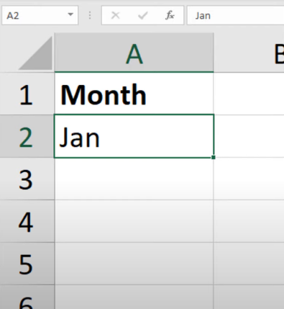

* Jan, Jan, Jan
* Feb, Mar, blank cell
* Feb, Mar, Apr
* FEB, MAB, APR
* Jan, Feb, Mar

#### **Q3. Which formula is NOT equivalent to all of the others?**

* =A3+A4+A5+A6
* =SUM(A3:A6)
* =SUM(A3,A6)
* =SUM(A3,A4,A5,A6)

#### **Q4. To round up a value to the nearest increment of your choice, such as the next five cents, what function should you use?**

* ROUNDUP
* MAX
* ROUND
* CEILING

#### **Q5. Which function returns the largest value amongst all values within the range H2:H30?**

* =MAX(H2:H30)
* =MAXIMUM(H2:H30)
* =LARGE(H2:H30,29)
* =UPPER(H2:H30,1)

#### **Q6. In the image below, what does clicking the button indicated by the green arrow do?**

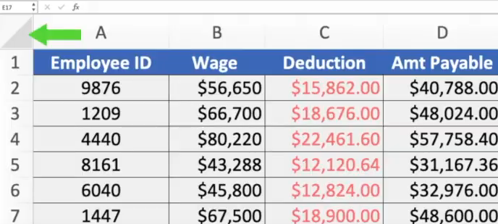

* Hides or shows the formula bar.
* Selects all.
* Hides or shows the ribbon.
* Selects objects.

Q7. "One can pick out just the data he needs, based on parameters set by him within MS Excel." Which feature of the MS Excel does help in doing so?

Basic Maths

Conditional Formatting

Look up formulas

Pivot Tables

Sorting and Filtering

Option 3 : Look up formulas

Q 8. If cells A1 and A2 are empty, what will be the value of the following Excel formula?

=A1*A2

1. 1
2. Name? error
3. 2
4. Value! Error
5. 0

ANs 0

Q9.

Q10.

#### **Q11. In the worksheet below, you want to copy the formatting of cell A1 into cells B1:D1. Which approach (see arrows) accomplishes this the most efficiently?**

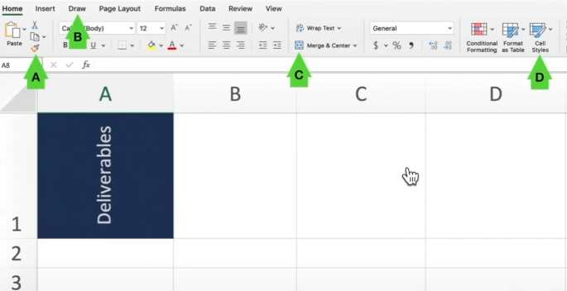

* B
* C
* A
* D
* Ans B

Q12. What tool would you use to prevent the input in a cell of a date outside a specific range?

￼ Protect Workbook

￼ Watch Window

￼ Data Validation

￼ Filter

13.Which tool used to join some cells and place the content at the middle of joined cells ?

* From insert tab choose Merge and Center
* Click on Merge and Center tool on home tab
* From view tab click on Merge cell check box
* None of the these

14.Which among following option is not available in Paste Special dialog box ?

* Divide
* SQRT
* Subtract
* Add

15.Which Key Is Used For Help In Ms Excel ?

* F2
* F1
* F3
* None of these

16.

17.in MS-Excel__________ short cut key is used for hiding row.

* Ctrl + H
* Ctrl + 7
* Ctrl + 9
* None of the above

Q18**. You need to determine the commission earned by each Sales Rep, based on the Sales amounts in B3:B50 and the Commission rate specified in cell A1. You want to enter a formula in C3 and copy it down to C50. Which formula should you use?**



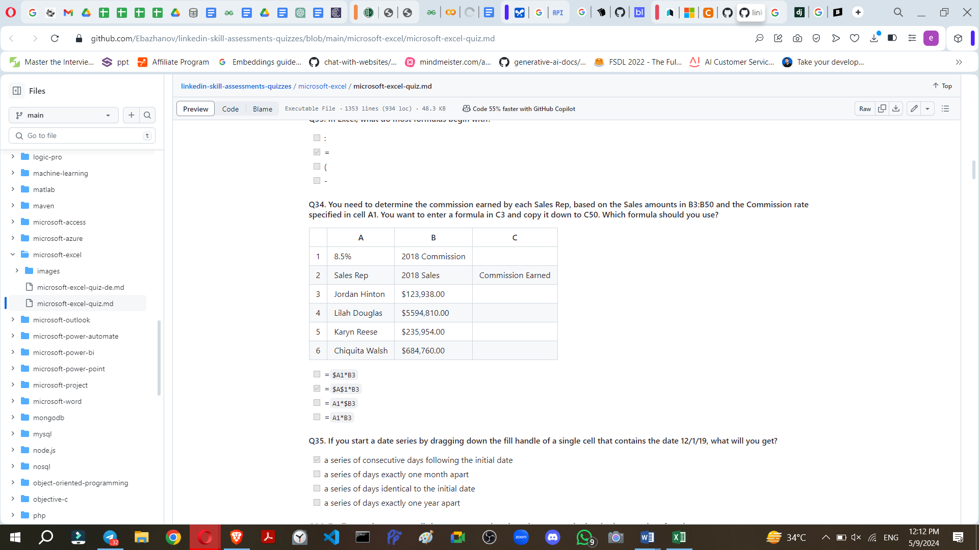

* =$A1*B3
* =$A$1*B3
* =A1*$B3
* =A1*B3

Q19. Write the FOrmula to calculate the following.

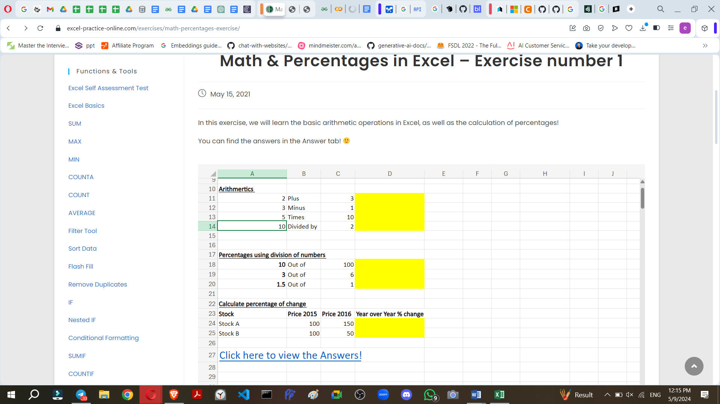

=============

Reference

<https://excel-practice-online.com/exercises/math-percentages-exercise/>

<https://testbook.com/objective-questions/mcq-on-ms-excel--5fb69e13c4364a4373cfdb75>

<https://github.com/BDFD-LearningGround/Coursera_Everyday-Excel-Specialization/blob/main/Module%202%20Everyday%20Excel%20Part%202/M2W2%20Quiz.pdf>

<https://github.com/Ebazhanov/linkedin-skill-assessments-quizzes/blob/main/microsoft-excel/microsoft-excel-quiz.md>